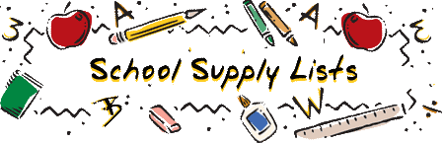

Belair K-8 School
First Grade
2023-2024
Dear Parents,
Listed below are the supplies that your child will use in first grade. Due to limited storage space, please send only those items listed below.

- 1 Bookbag
- 2 Boxes of #2 Pencils
- 4 Boxes of Crayons (24 count)
- 2 Pair of Headphones (Label with your child’s name)-NO Earbuds please.
- 4 Packs of Glue Sticks
- 1 Zippered Pouch
- 1 Pair Safety Scissors (rounded tips)
- 2 Folders – Pockets Only- 1 Red and 1 Blue (Needs to be Durable)
- 2 Marble Composition Books (100 pages each) – Wide Ruled
- 2 Packs of Expo Fine Tip Dry Erase Markers (Black)
- 1 Large Box Facial Tissue
- 1 box Ziploc bags (quart size/sandwich bags)
- 1 Big bottle of Hand Sanitizer
- Optional- Water Bottle

